AME 493 (Fall 2013)

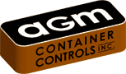

AGM Container Controls

Value of my

Engineering Internship

Clayton Stewart

4/12/2014

Table of Contents

1. Introduction
2. Projects
   1. Automated CMMs
   2. ITR
   3. Integration of MIL-STD-1916
   4. Electronic Filing
   5. Hot-Board
3. Conclusion
   1. Value of my Education on my Internship
   2. Value of my Internship on my Education
   3. Future Career Plans

Section I. Introduction

During the spring semester of 2013, I worked for AGM Container Controls in the Quality Assurance (QA) Department. In addition to my regular duties, I also completed numerous projects for the Department. The five most impactful projects I completed include: 1) researched automated coordinate measuring machines (CMMs) helping AGM’s QA Department purchase an appropriate CMM; 2) created a macro driven excel program that completely eliminated employee data entry errors and increased productivity when receiving product from purchase orders (POs); 3) created an inspection/test worksheet to help AGM meet the requirements of Military Standard 1916; 4) created a program that automatically indexed (electronically filed) certifications and paperwork for product received on POs; and 5) created an electronic “hot-board” to help AGM’s QA and Production Departments communicate priorities and track received product.

In the following sections I will address why each of these projects was both impactful for the department as well as my development as an engineer. I was originally assigned the position of inspector, however I quickly proved myself to be more useful as a programmer and developed a lot of software to help make the department more efficient. I was very fortunate to work with David Dolana, who had recently been promoted to manager of the QA Department, for being very open minded to my role in the department and let me have input into where I thought my contributions could be most effective.

Section II. Projects

Project 1 Automated CMM

While working in the QA Department, I originally spent a lot of time operating and programming a manual CMM. My CAD classes helped prepare me for this position by familiarizing me with drawing documentation. Improving my SolidWorks abilities in ABE 221 (Introduction to CAD) was also very helpful as AGM also utilizes this software, as I needed to interact with it on a daily basis.

Many of the measuring techniques that the department utilized were prone to errors as well as not being accurate enough to meet a few of the more complicated geometric dimensioning and tolerance (GD&T) requirements. I suggested to my boss that we research into automated CMMs. He agreed that the department would require an automated CMM going forward in order to be a keep up with ever increasing tolerance demands. During this project, I helped develop the specifications that would meet our quality requirements as well as sizing an appropriate machine. I then researched into several distributors of CMMs and discovered a conference that would be showing live demonstrations of several machines. I saved my boss hours of time researching which vendors he would be interested in visiting and eliminating those that would be a waste of time.

This project was valuable to my development as an engineer because I realized that I have the ability to make a larger impact than a typical inspector. This proved particularly important in my following projects, as I was able to step beyond my regular duties to have a greater impact.

Project 2 Inspection Test Report

A large portion of an inspector’s job included the recording of measurements as well as filing paperwork. All of the inspections were completed on paper and then manually filed away without recording any of it in an electronic database. This seemed like a wasted opportunity to me. I suggested that we develop an Excel based Inspection Test Report (ITR) that we could use to record and keep a history of measurements. Previously, the department would pick a percentage of parts at random from the given job and inspect them hoping that they all fell in tolerance. By using statistics we were able to better understand the distribution of dimensions and determine which parts should be accepted or rejected. My boss was very enthusiastic about this idea and encouraged me to shift my focus in this direction, as it would increase the department’s efficiency and effectiveness.

While developing the ITR I taught myself the programming language Visual Basic for Applications (VBA). While my education in Mechanical Engineering did not teach me a ton about programming, it did expose the building blocks to let me be successful in this endeavor. Many of the techniques that I learned in my earlier programming classes came back to me as I began to see their benefits. While developing this program, I worked with David Dolana to develop a flowchart governing how to use the ITR and verifying that it would meet the department’s needs. This flow chart is shown below.

 [Flow-Chart of Quality Assurance Processes]

This flowchart resulted in the following excel spreadsheet, the ITR, being constructed.

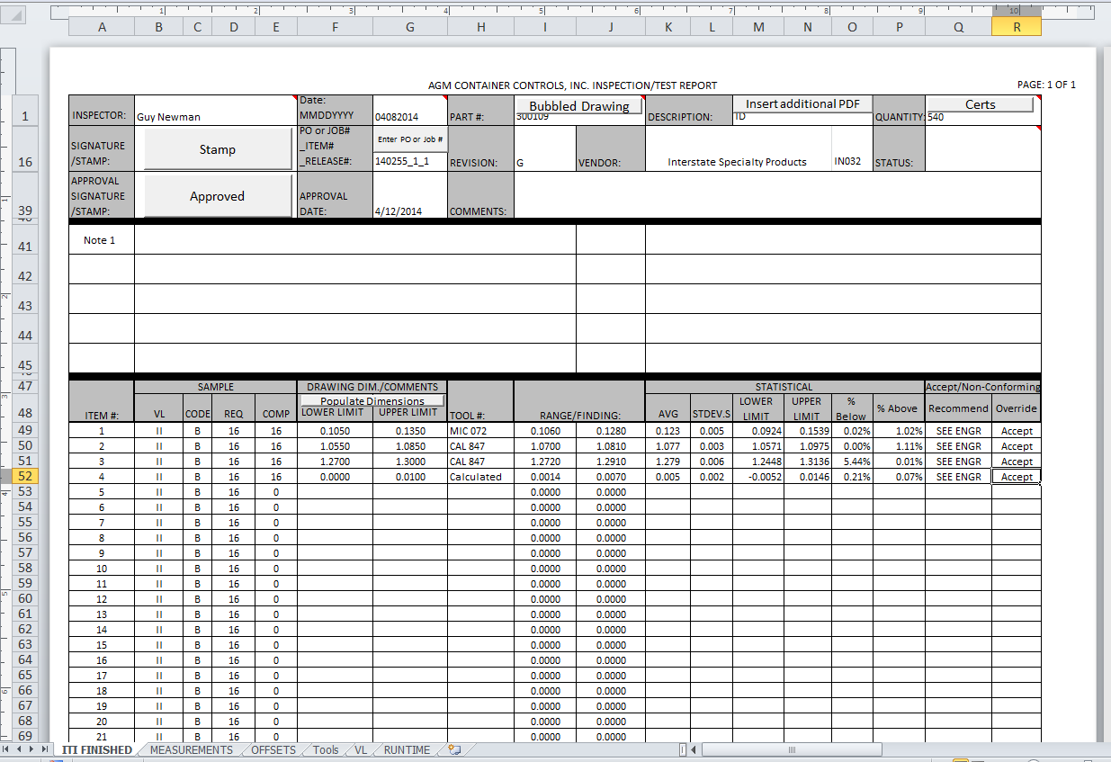

[Main ITR Page]

While working on the ITR I was introduced to SQL and the company’s databases, in order to automate paperwork. I taught myself how to query against the database to find information related to the given job or PO. I was able to tap into AGM’s database utilizing SQL to autocomplete large portions of the ITR by simply having the inspector enter the job number or PO associated with the given product.

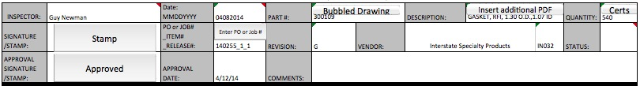

[ITR Header Auto-Filled]

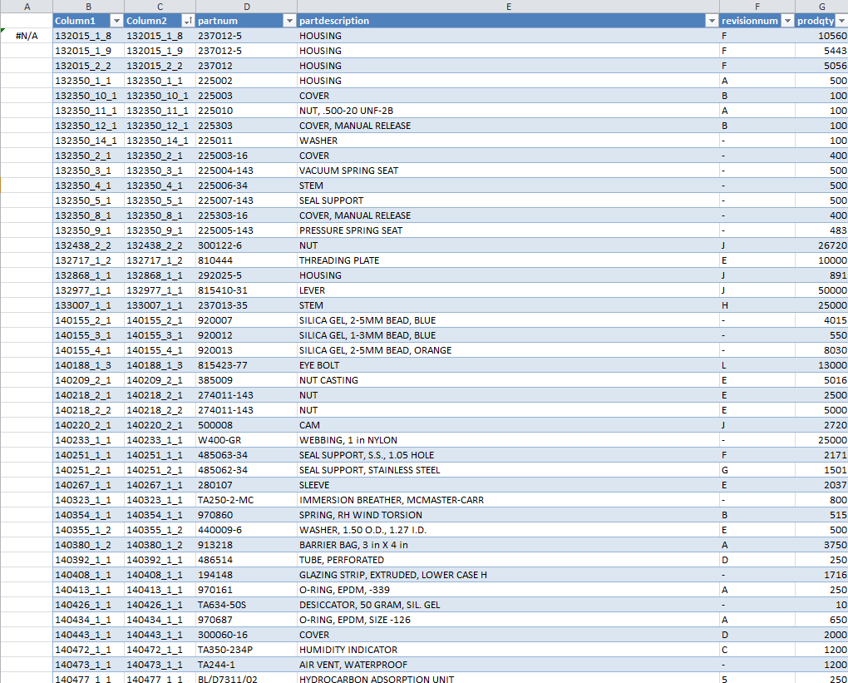

[SQL Data Embedded into Excel]

Using my education in statistics, I was able to predict the mean and standard deviation of the measurements and thus predict the distribution of a given a sample and determine the percentage of parts that would fall above and below the given tolerance utilizing six sigma practices. The program would then make a recommendation on whether or not the part should be accepted, however a manual override was provided to allow David Dolana to make the final decision. This proved to be a useful tool that my boss was able to use to justify his decision to accept or reject product.

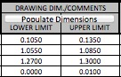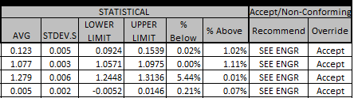

[Tolerances and Statistical Calculations]

While logging measurements, inspectors would occasionally enter information incorrectly, or miss a digit, causing the measurement to be off by an order of magnitude. This would skew the statistics, so I utilized conditional formatting to indicate to the inspector whether or not the measurement was within the provided tolerances. This optimization dramatically reduced data entry errors.

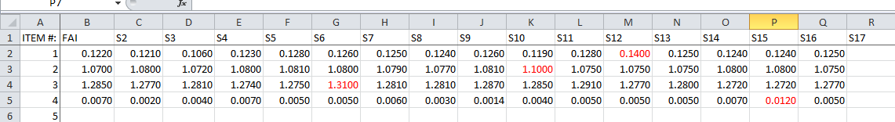

[Measurements Out of Tolerance Marked Red]

An additional feature, requested by David Dolana, was that the tools used to record the measurements could be traced. Unfortunately, the tools used in the QA Department had not been cataloged. I designed an excel sheet that allowed the inspectors to catalog the tools and then linked the tools sheet to the ITR such that the inspectors could select the tool that they used. This feature allows the company to identify all product measured by a given tool, in the circumstance that the tool is proved to be out of calibration, so a recall of product could be initiated.

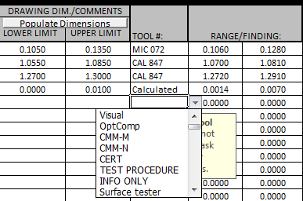

[List of Available Tools]

Another major feature of the ITR was the ability to attach additional documentation, such as Drawings or Certs, so that when the ITR was indexed into the documents database, all of the paperwork that was related to the document could be easily located. I gave the inspectors three buttons which would launch a windows explorer, from which they could select the document that was relevant.



[Buttons to Attach Relevant Paperwork]

I won’t bore you with all of the details of the ITR, however I continued to add additional features to it throughout the semester so that by the end it was saving each inspector over one hour each day. The impact that this project had on the department has fueled my passion for programming. While in school, I had never built a large-scale program, and therefore I was unable to appreciate how effective programming could be. This semester, I was able to witness first-hand the hours of time each inspector saved by having sheets that filled themselves out as well as the headaches avoided by eliminating errors in data entry.

That said I did learn a potentially even more valuable programming lesson while building the ITR. In the beginning, many of my techniques were amateurish, and I often utilized massive subroutines because they worked. Latter on this mistake turned the ITR into a “rats nest,” and applying updates to the ITR were significantly more difficult because I needed to update code in several locations. Since developing the ITR, I have focused on improving my coding strategies so that I do not add additional mental strain on myself. I have found that often times one can make a program or function significantly more useful by using a slight abstraction. These abstractions make my code significantly easier to read as well as update.

Project 3 Integration of MIL-STD-1916

During my internship, my boss discovered that the department had been following a Military Standard that was out of date. He tasked me with researching the requirements of the new Standard and reporting to him what updates needed to be made to the department. The main effect that the new Standard had was that instead of using automatic qualifying (AQ) quantities to measure, we now needed to use a new statistical tool, verification levels (VL) declared on the contract, to determine what percentage of parts needed to be measured.

I then took the matrices that were used to determine the VL and built it into the ITR so that quantities that the inspectors needed to measure would be automatically calculated for them. This update to the ITR both brought the QA Department up to modern requirements as well as simplified the transition for the inspectors who no longer needed to spend time training on that aspect of the new standard.

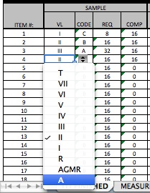

[ITR VL Selection]

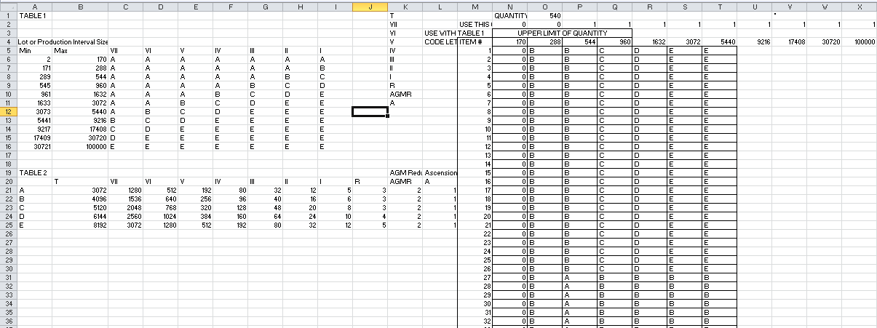

[Verification Level Calculations Page]

My schoolwork was an important factor to my success because I was able to read very dense material, like a physics textbook, and determine what applied and what didn’t. I believe that this ability will prove helpful throughout my career, as I am not intimidated by large amounts of technical documentation.

Project 4 Electronic Filing

Many hours were spent indexing documents manually in the document database, and this repetitive process was highly prone to typos. I utilized the same SQL queries that located the additional information, associated with the job or PO, to both auto-fill the ITR as well as automate the indexing process and prevent careless errors that resulted in lost documentation.

I also noticed that one of my co-workers spent a lot of time digging through documentation to compile certification packets proving the specs of the material that product was built form. I worked with Tom Christie, AGM’s Chief Information Officer, to develop a program that compiled these documents programmatically utilizing recursive SQL queries. These SQL queries would dig through the tree-like structure of the database searching for all of the POs associated with the given job. Once all the leaves of this tree, the POs, were identified, the program would search our documents database to locate the paperwork associated with the given POs. It then compiled all of these documents into a, sometimes multi-hundred page, PDF with a Table of Contents and identified any old POs that could not be located because they hadn’t been indexed in the document database. This automation reduced a job that took over four hours a week to a button click.

Once again, these automations were more than enough evidence to convince me of the value of programming. I think that regardless of what career I pursue, I will always have a future in programming as it is a life-long skill that I can constantly improve in.

Project 5 Hot-Board

The Production and QA departments often had problems communicating with each other which jobs were the “hottest” and what should have a higher priority. The QA Department utilized a dry erase board in which everything written on it was “hot.” This resulted in everything as well as nothing being “hot.” There was also no good system in place to track received product or determine which inspectors were working on what, so inspectors would waste time looking for product that was already in the process of being inspected. All of this miscommunication led to product shipping late as well as upset customers.

In response to these problems, I designed an electronic version of this hot-board that allowed the managers to assign priorities to jobs and inspectors to declare which jobs they were working on. For this project, I utilized Visual Studio and .NET programming combined with a SQL database to alert inspectors when jobs were completed and ready for inspection. It also notified inspectors of POs that had been sitting in the QA department for over 20 days, marked red, so that that product could be inspected and received, or rejected, before the return period expired.

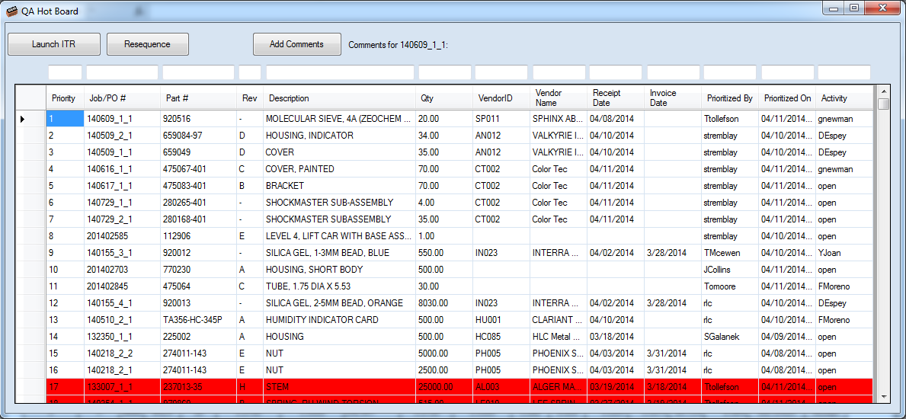

[QA Hot-Board]

This was by far the most advanced program that I created during my internship. While developing this piece of software, I designed my own SQL database to interact with my front end Graphical User Interface (GUI). I applied the modern software technique of separating the GUI from the database utilizing an interfacing layer. This strategy proved very effective for making updates to the program and maintaining sanity while developing a larger-scale program.

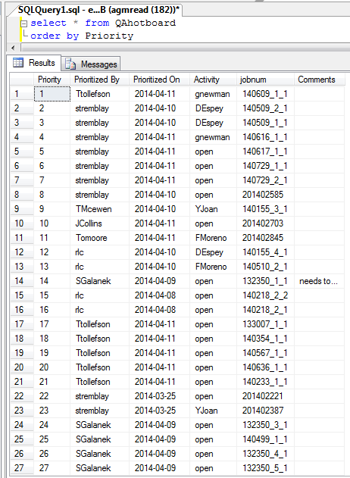

[SQL Database Governing QA Hot-Board]

This project exposed me to modern techniques of designing database driven programming and has taught me how to programmatically design SQL commands to insert, update and delete information from the database as well as how to parameterize a SQL Query to protect the database from a SQL injection.

Section III. Conclusion

1) Value of Education on Internship

I was surprised to find how quickly I was able to translate my experience in other languages to .NET and VB, and the logical thought processes that I developed during my tenure in Mechanical Engineering have proved very helpful during my internship as well as for quickly understanding both VB and SQL. AME 302 (Numerical Methods) proved especially helpful for me during my internship. While that class was based on MatLab programming, many of the concepts still applied to VBA.

2) Value of Internship on Education

As is evident, my internship has proved to be an incredibly valuable experience. I learned many skills that any company would value, and learning how to program has improved my ability to think logically and organize my thoughts.

Since this internship, my interest in programming has only grown. My interest has led me to take additional programming classes to improve my technique as well as my understanding of programming concepts.

I would have never imagined that I would have come as far in programming as I have in the past year, and I am very excited about my future, as programming is a skill set in which one can be a life-long learner. My strategies in programming have improved significantly with experience and I now understand the benefit behind researching and utilizing best practices.

3) Future Career Plans

While in QA I had to thoroughly learn the business processes governing how product moved through the QA Department in order to design and code the ITR. My ability to learn a given departments processes and find ways to automate and simplify has earned me a promotion into AGM’s Information Technology (IT) Department as a programmer. I currently develop .NET programs that interact with our SQL database to help automate business processes as well as increase communication and expose additional information. My automations have saved AGM hundreds of hours annually, and I’m sure that this ability will prove valuable throughout my career, whomever I work for.

I am glad that I decided to pursue Mechanical Engineering for my major as I have found that traditional professors helped me to better understand many of the thought processes governing the engineering discipline. That said, I am very excited to have developed such a passion for programming, as I have found that computer science has lots of information and examples on the internet making it an excellent way for me to continue my education after college.